Controlling Sample Exposure to Temperature Variability

Posted by Chris Parsons, Ph.D on Mar 19, 2015 12:10:47 PM

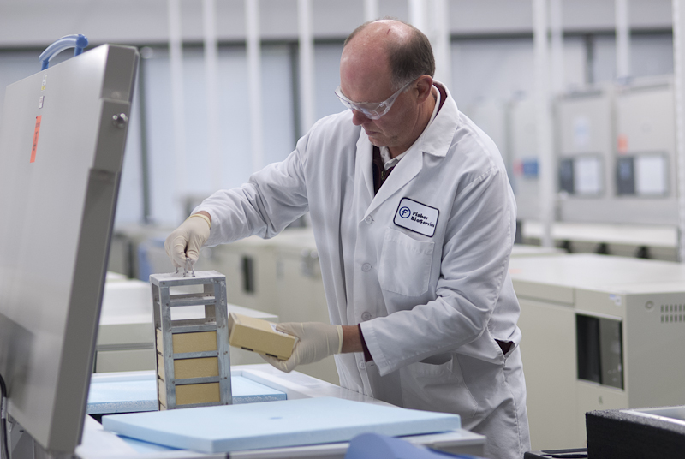
Maintaining the appropriate storage temperature of a clinical specimen/drug vial is critical for the downstream use of that sample. However, during their life cycle specimens are handled far more often than one probably realizes, and each handling event presents the opportunity for a temperature shift that may compromise the integrity of the sample for downstream research. Multiple and/or rapid temperature fluctuations can generate changes in enzymatic and other molecular activity that can result in loss of efficacy and potency or effect diagnostic results.
When considering temperature management, most people think about it in terms of the bigger picture. That means focusing on the storage unit: is it monitored, is there a back-up generator, is a technician on call, and so forth. This makes sense, as a specimen can spend years in a freezer without being disturbed. Given that an ultralow (-80°C) freezer can hold more than 50,000 specimens, failure of a single unit can be catastrophic to a collection.
However, there are numerous, transient factors to consider regarding sample exposure to temperature variability. These considerations receive a significant level of attention in the operation of our biorepositories. For instance:
- In order to be received, scanned, retrieved, processed, and/or shipped, samples must be handled, and the greater the handling time, the greater the opportunity for temperature shift to occur. Even if some of the handling is automated, the samples will almost assuredly experience some kind of temperature shift, as samples stored in automated ultralow or cryogenic units are manipulated by robotics in a -20°C environment.
- The smaller the volume of a sample, the faster it warms, narrowing the acceptable time-out-of-temperature.
- The colder the storage environment, the greater the temperature shock when exposed to ambient temperatures or even other sub-freezing temperatures. You might think “frozen is frozen,” but the difference between a cryogenic environment (-150°C and below) and dry ice (-78.5°C) is an absolute change in temperature of more than 70°C.
- The nature of the material (aliquot of plasma vs. single dose of manufactured cell therapy) is critical in determining the acceptable time-out-of-temperature.
- Similarly, does the nature of the material allow for temporary changes in temperature? Can the samples be shipped at a different temperature than the storage temperature without effecting their usefulness?
From a sample receiving perspective, time out of temperature is best managed by processing the samples in the same type of environment as they were received in (unless specific instructions indicating otherwise are provided). That is, specimens shipped to the biorepository on refrigerated gel packs can be inventoried on wet ice, gel packs, or in a cold room; drug vials arriving in vapor phase nitrogen (a dry shipper) are processed and moved to the storage unit in an LN₂ cryocart fitted with a temperature monitor. Samples arriving on dry ice are in turn processed on dry ice using a Cryocradle™ to minimize temperature variability.
Once specimens are placed in a storage unit, time out of temperature is managed through controlled access to the unit. Open-door time is kept to a minimum to prevent the unit’s temperature from rising too high, and then the unit is allowed to recover before re-accessing it.
When retrieving material from storage (whether for shipment or for additional processing by our laboratory), a similar approach is followed; specimens are handled and shipped in an environment as close as possible to their storage environment.
One of the best ways to minimize potential effects of time out of temperature is to know the results associated with such an event before it occurs. Test samples for stability of the targeted analytes, if data is not available in the published literature. Much is already known: for example, a vial of an autologous stem cell therapeutic may not be able to exceed a threshold of -150°C for more than 30 seconds without effecting efficacy. Conversely, according to the manufacturer of dried blood spot cards, blood preserved on a card and shipped on dry ice may suffer no deterioration, even if the recommended long-term storage temperature is -20°C.
Minimizing the potential effects of time-out-of-temperature is not a one-size-fits-all solution. Consider the nature of the material to be stored, the potential downstream assays, aliquoting needs (to minimize freeze-thaw cycles), and other factors. By understanding what temperature fluctuations and durations are acceptable (if any), and providing written criteria for sample handling to the custodians of your research material, you will gain peace of mind regarding the integrity of your critical, potentially life-saving, specimen collection.

